Missouri Numismatic Society
Procedures Manual

February 21, 2024
Missouri Numismatic Society
P.O. Box 410652, St. Louis, MO 63141-0652

GENERAL

The Missouri Numismatic Society (MNS) will be directed by a Board of Directors (Board) consisting of Officers and Governors.

Business issues may be presented for review, discussion and/or approval by the Board or by any MNS member. Issues requiring voting must be motioned and then seconded by a Board member. A majority vote is sufficient to approve the issue.

Every Board member has one vote except for the President, who is non-voting and may vote only to resolve a tie.

Changes to these procedures and appendixes may be submitted to the Board by any MNS member. Changes must be approved by two-thirds majority of the Board in attendance at a Board meeting AND a simple majority, 51%, of members attending a general meeting. The one exception to this is that Appendix B – Table of Values does not require approval by the members.

The board members are an all-volunteer position. There are no paid positions.

OFFICERS

Composition
There are five (5) officers elected to a term of two years each. The President, Vice-President, Recording Secretary, Corresponding Secretary and Treasurer are elected in even–numbered years.

General Responsibilities
- Each officer shall attend board and general meetings regularly.
- Each officer shall execute the duties of his (her) office as defined in the By-Laws and Procedures Manual.
- Each officer shall be an ex-officio member of each committee he (she) oversees.
- Officers, along with the Board of Governors, must approve and/or modify the Show Committee’s compensation as presented by the Show Committee. Compensation is in the form of a Volunteer Appreciation party and must be approved by two-thirds majority of Officers and Board of Governors, excluding President.

President
1. The President is the Chief Executive Officer for all board meetings and general membership meetings.
2. Conduct annual review of Society policies and procedures.
3. Delegate authority to each officer and committee chairman as specified in the Procedures Manual and
in accord with established policies of the Board of Directors.
4. Monitor activities of all officers and committee chairmen.
5. Preside over election of Officers and Governors as described in the By-Laws.
6. Receive regular reports from each officer for review at Board meetings.
7. Appoint a representative responsible for the relations with the American Numismatic Association and
the Central States Numismatic Society.
8. Appoint an Audit Committee.
9. Appoint an M.N.S. Journal Editor.
10. Appoint a General Show Chairperson. This person will appoint a committee to arrange the annual coin show.
11. Appoint a Nominating Committee to establish a slate of nominees for all offices and the Board of Governors as prescribed in the By-Laws.
12. Appoint a Youth leader.
13. Locate a meeting site for regular Board meetings. Meetings are held in the following months if necessary: February, March, April, June, July, September, October, and November. Additional meetings are at the President’s discretion. These meetings may include a meal, without alcohol, paid by the MNS. The meetings will be held the week prior to the general meeting.

Vice President
- Preside over the Board and General Meetings in the absence of the President.
- Appoint a General Meeting Committee to secure a meeting place for the monthly meeting and arrange for the program and refreshments.
- Appoint a Banquet Committee to arrange the annual Awards banquet.
- Appoint a Membership Committee.
- Appoint, with the concurrence of the President, a Nominating Committee to establish a slate of nominees for all offices and the Board of Governors as prescribed in the By-laws.

Recording Secretary
- Record and report the minutes of each monthly general meeting and each Board of Governors meeting.
- Deliver to the President a list of unfinished business or projects for analysis.
- Receive all membership applications and the appropriate dues, assign membership numbers, add the names to the mailing list, and transfer the collected dues to the Treasurer at the earliest opportunity.
- Issue appropriate membership cards to each member and maintain a file of membership.
- Maintain a listing of membership numbers in numeric sequence with the member’s name and date of membership.

Corresponding Secretary
- Be responsible for all official correspondence, including mailings and social media, to and from the Society.
- Issue a Newsletter prior to each general meeting. This Newsletter will identify the date, time, location, and speaker of the next general meeting.
- The Secretary shall requisition from the Treasurer the necessary funds for purchase of correspondence supplies and disburse the same for the day-to-day needs of MNS.
- Appoint a Publications / Social Media Committee.
- Appoint a Sick and Welfare Committee.
- Maintain a listing of the membership and work with the Recording Secretary to maintain records.
- Remove non-renewed members from the correspondence list after March of the current year.

Treasurer
- Receive and deposit all monies of MNS, noting on the deposit slip the reason(s) for the funds (i.e., dues, show receipts, donations, etc.).
- Report the checking and investment account balances at each regular meeting. Publish a complete accounting annually, when requested by the President or majority vote of the Board of Governors.
- Maintain an accounting system and make available to the Board of Governors a balance sheet annually.
- Receive and pay all authorized invoices.
- Maintain control of all assets of the Society, including but not limited to the post office box, storage locker, investment certificates and all other valuables. An inventory list shall be maintained for the Board. This inventory list will identify all assets by description, location, and person responsible for. This list will include items such as: cases, laptops, etc. and will include items used by the Coin Show. If desired, the Treasurer may establish a reasonable dollar minimum value for items that must be included on this list. Upon request by the Board the Treasurer will produce any item on this list or provide access to the item.
- Coordinate with the Show Committee Chairman and receive the final proceeds with the final Show Report.
- Present, along with the Show Chairman, the final Show Report to the Board prior to the end of the calendar year.
- Annually review club insurance coverage (March), case insurance (September), lease arrangements (storage locker in August), and all other financial obligations of the Society with appropriate recommendations.
- Forecast a budget for each committee in concert with the other officers and submit it to the Board prior to the third Board meeting of each year.
- Oversee the preparation and submission of Federal and State forms, the State incorporation fee, and notifies the Secretary of such actions.
- Appoint the Property Committee.
- Disperse scholarship funds to attend the ANA Summer seminar sessions. Eligible applicants must be a club member for 2 years. YN’s with less than a 2-year membership may have their eligibility waived by an approval vote of 2/3 of the board. Adult scholarships are $1500.00 and YN scholarships are $750.00. If a person is unable to attend that year, they can go the following year. If unable to attend the following year, they must return the funds and are eligible to reapply later.

BOARD OF GOVERNORS

General Premises
- The Board of Governors consists of seven members elected to serve a term of two years. They are to be elected in even-numbered years.
- Each Governor must be a regular member and in good standing with the Society for two years to be eligible for nomination.
- Each Governor will regularly attend the Board and General meetings.

COMMITTEES

Not all Committees listed and described below may be staffed and active at the same time. As the need is identified, the Board may activate and staff certain Committees. This allows for optimization of a limited number of resources available for Committee work. Additionally, the functions of certain designated Committees may be performed by a single, designated individual (Officer, Governor, or Member).

Nominating Committee
- Is appointed by, and responsible to, the President.
- Consists of three individuals, one of which may not be a Board member.
- Supplies list of nominees to the Corresponding Secretary for publication in the Newsletter.

Property Committee
- Is appointed by, and responsible to, the Treasurer.
- Annually surveys the space and location needs for
  - Case and equipment storage
  - All other physical assets.
- Reviews the current building lease and advises the Treasurer on lease renewal.

Audit Committee
- The Audit Committee is appointed by, and responsible to the President.
- The Audit Committee shall review and certify the accounts of the Treasurer, including such physical investigation as deemed necessary.
- The Audit Committee shall report the findings to the President, the Treasurer and Board of Governors as prescribed by the By-Laws or as requested by the Board.
- The Audit Committee will meet when a new Treasurer takes office or when requested by the President.
- An Internal Audit is performed biannually.
- An External Audit is performed at direction of the Board no more than every four years.

Banquet Committee
- The Banquet Committee, including Committee head, is appointed by, and responsible to the Vice-President.
- Selects the location, meal and entertainment for the annual Award party held in December.
- Determines amount to charge MNS members and guests for the banquet. This amount is approved by the Board.
- Designs and distributes the annual gift to the membership.
- Secures and presents all awards and certificates.
- Submits all invoices to the Treasurer.

Membership Committee
- The Membership Committee, including Committee head, is appointed by, and responsible to, the Vice-President.
- Establishes new member goals and mans the membership table at the annual coin show.
- Prepares an informative pamphlet describing the MNS to be given to prospective new members.
- Appoints a greeter to welcome new members and explain the various club activities. This greeter will record the attendance at the general meetings and assist with awarding the attendance prizes.

Show Committee
- The Show Committee is appointed by, and responsible to the Show Committee Chairman.
- Assists in activities when asked by the Show Chairman.
- Determines Show Committee Chairman’s compensation, without direction from the Show Chairman. Compensation is in the form of a Volunteer Appreciation Dinner, based on a predetermined amount approved by the Show Committee, not to exceed $2,000.00.
- Accounts to the Treasurer for all expenses and income from the show.
- Secures the necessary manpower to run the show.
- Compensation for excessive travel while volunteering to distribute flyers and other show activities will be a onetime monetary reimbursement of not more than $50.00, with gas receipt.

General Meeting Committee
- The Meeting Committee is appointed by, and responsible to, the Vice-President.
- Contracts for a meeting place ample for the number of members normally attending the monthly meeting.
- Assures that a program of interest to the membership is presented at each meeting.
- Assures the refreshments are available.
- Assures that attendance prizes are available at each meeting.
- Submits invoices to the Treasurer for any budgeted expenses.
- General Meetings are held on the fourth Wednesday per month from January through November except for July and November (no meeting is held in July due to the Coin Show), (November’s meeting will be on the third Wednesday due to Thanksgiving) beginning at 7:00 pm CT at the designated location (currently the Creve Coeur American Legion Hall). The early talk will begin at 6:30.
- The monthly newsletter is sent out by the Corresponding Secretary prior to each General Meeting outlining the program for the meeting, club news, items of general interest, future coin shows, officers and governors and future meeting dates.
- Minutes from each General Meeting are recorded and are reviewed by the Recording Secretary with the membership at the next General Meeting.
- Bourse may be set up at 6:00.

Sick and Welfare Committee
- The Sick and Welfare Committee is appointed by, and responsible to, the Corresponding Secretary.
- Reports at the meeting of any sick, hospitalized, or deceased members.
- Sends cards to members who are ill or incapacitated and to families of recently deceased members.
- Submits invoices to the Treasurer for any budgeted expenses.

Publications / Social Media Committee
- The Publications / Social Media Committee is appointed by, and responsible to, the Corresponding Secretary.
- Accesses the MNS Post Office Box prior to the Board and General Meetings.
- Oversees publication of the Missouri Journal of Numismatics as defined by the Procedures for the Journal.
- Maintains the MNS Website under the responsibility of the Web Master.
- Maintains other social media sites as established by the MNS (Facebook, Twitter, etc.).

Young Numismatist (YN) Committee
- The Young Numismatist Committee is appointed by, and responsible to, the Youth Leader.
- Maintains and enforces the Young Numismatist Code of Conduct, Appendix A.
- Coordinates a YN meeting prior to the General Membership Meeting.

ANA and CSNS Club Representative(s)
- Appointed by, and responsible to, the President.
- Reports annually to the Board.
- Sends information on current Society activities to each organization for publication, when appropriate.
- Coordinates the ANA Numismatic Diploma Program. Reports the status of the program to the general membership annually.
- Requests the Education Award certificates from the ANA for the general membership meeting speakers. The certificates will be presented at the annual awards banquet.

MNS Club Auction Coordinator(s)
1. Held at the discretion of the MNS Board.
2. Appointed by, and responsible to, the President.
3. MNS typically holds a yearly MNS Club Auction at the April General Meeting.
4. Members only may submit up to 5 (five) auction lots for inclusion in the MNS Club Auction.
5. Lots to be included may be displayed for viewing at the March General Meeting.
6. The MNS Club Auction Coordinator(s) established the MNS Club Auction Rules (see Appendix D) which may be revised each year.
7. The MNS Club Auction Coordinator(s) manages and the run the auction.

MISSOURI JOURNAL OF NUMISMATICS

Editor
- Is appointed by the President.
- Coordinates and supervises all phases of the Journal.
- Arranges for publication of the Missouri Journal of Numismatics.
- Determines presentations at the monthly membership meeting for both the General Meeting and the Early Meeting.

General Premises
- A major research article should be included in each issue.
- Each journal should contain articles to accommodate varied interests, coins, paper currency, medals, tokens, etc., with a slant toward Missouri related subjects, if possible.
- In-house reports include the President’s Report, Ancient Coin Study Group Report, Calendar of Events and Junior Membership (Young Numismatists) Report.
- A Table of Contents occupies the first page.
- A program inserts consisting of a dealer list and dealer floor plan is included.
- Editing choices are made at the discretion of the editor.

Guidelines
- Major research article should:
  - Be original research or analysis.
  - Properly credit source material.
  - Emphasize numismatic rather than just historical information.

- President’s Report:
  - Should be written as a mid-year report on the Society’s activities.
  - Includes a listing of officers and board members.

- Ancient Coin Study Group (ACSG) Report (This will be included in the Journal if made available by the ACSG.

- Calendar of Events
  - Lists all area numismatic events. Compile from sources listed in this section. Also check trade paper for listings.
  - Separately lists the MNS and YN programs for the upcoming year.
  - Separately lists the World Coin Club programs for the upcoming year. Secure information from WCC Program chairman.
  - Separately lists the Ancient Coin Study Groups programs for the upcoming year. Secure information from Ancient Coin Study Group Program chairman.
  - Separately lists the meeting schedules for the St. Louis Numismatic Association, Metro East Coin & Currency Club and Dupo Coin Club. Obtain information from the respective Presidents or Program chairmen of these clubs.
  - Dates for the monthly general membership meetings for the remainder of the existing year and the following year will be identified along with the presentation at the meeting and the location of the meeting.

- MNS Membership Report (Young Numismatists)
Includes activities with photos if possible. (Photo by permission only)

- Miscellaneous articles
  - Should provide a backlog of 1-, 2-, or 3-page articles to fill pages if needed.
  - May include reprints if no current copyright exists and the article has merit.
  - May come through encouraging new members to write short articles on their specialties.

- Table of Contents
  - Uses separate listings for articles and for advertisers.
  - Is placed on page 1.

Advertising
- Is under the charge of the show committee advertising manager.
- Refer to Appendix B for values of advertising prices.

ANNUAL MNS COIN SHOW

General Premises
- The annual coin show is the major fund raiser for the MNS.
- The annual three-day show is held during the summer.
- Members who volunteer and assist at the show may receive complimentary meal coupons at the show and a dinner party as a thank-you for their assistance.

Show Chairman
- Is under the oversight of the President.
- Supervises all phases and committees relating to the annual coin show.
- Selects chairmen and members for the Show Committee.
- Arranges the physical facilities for the show, establishes table and admission fees, arranges for exhibits, and awards, and arranges for security and advertising and all other necessary activities.
- Secures the necessary manpower to run the show.
- Accounts to the Treasurer for all expenses and income from the show.
- Issues a final report and balance sheet for the show operation within 90 days after the end of the coin show.
- Presents, along with the Treasurer, the final Show Report to the Board of Governors prior to the end of the calendar year.
- Show Committee Chairman plus one other Board Member, along with the President, contracts with the show site for the following year’s coin show.
10. Accounts to the Treasurer for all expenses and income from the show.

Committees Responsible to the Show Chairman
- Auction - may be contracted with a reputable firm.
- Bourse Chairman (may also be Show Chairman)
  - Ranks second only to the Show Chairperson.
  - Reviews bourse contract terms adding suggestions from the MNS Board.
  - Mails table contracts and dealer application forms.
    - Dealers from previous show are given first preference.
    - Bourse openings are solicited at the discretion of the Bourse Chairman.
  - Obtains badges, dealer signs and any other paraphernalia required.
  - Obtains merchant’s license and special events license from appropriate authority.
  - Decides if MNS cases and lights will be used or if they will be obtained from somewhere else.
  - Obtains shirts to identify MNS members and YN’s at the show.
  - Prepares program insert consisting of a dealer list and dealer floor plan included in Journal and distributed at Coin Show.
  - Oversees the issuance of early bird badges at the beginning of dealer set-up for a fee of $75.00 each, good for the duration of the show.

- Educational Displays
  - Are solicited from the membership.
  - Members who make displays for the show may be compensated up to $50.00.
  - Under the supervision of the Show Exhibit Chairman.

- Journal and Programs
  - Is under the responsibility of the Journal Editor.
  - Necessary information is to be supplied to the Journal Editor by all show committee chairmen.
  - The program insert will include:
    - Dealer list
    - Floor plan
    - Calendar
    - Membership application

- Property
  - Coordinates with Boy Scouts for help in setting up and breaking down show.
  - If MNS cases are used:
    - Obtains truck and volunteer driver.
    - Cases, keys, lights, signs, and miscellaneous equipment.
      - are removed from storage.
      - are issued with keys at the show site on the set-up night.
      - Fees for extra cases and lights are listed in Appendix B.
    - Show break-down begins after 4:00 p.m. on last day of Show.
    - Sees that all necessary society equipment arrives at the coin show and is returned to the proper storage area.
  - If MNS cases are not used:
    - Obtains cases from third party.
    - Show break-down begins after 4:00 p.m. on last day of Show.

- Publicity
  - Employs media coverage when available.
  - Includes advertising in (the following are suggestions. The actual ads will be determined on a show-by-show basis).
    - The Numismatist (free calendar listings).
    - The Coin Dealer Newsletter (paid display ad).
    - Coin World (paid calendar listings and display ad).
    - Numismatic News (free calendar listings and paid display ad).
    - The Bank Note Reporter (paid display ad).
    - Journal Newspapers (paid classified ads).
    - St. Louis Post Dispatch (paid classified display ads – 10 days – and free listings in the calendar section).
    - Local radio and TV stations (free community advertising).
    - MNS Show Website http://www.mnscoinshow.com/
  - Designs, prints, and distributes flyers.

- Registration
  - Dealer
    - Prepares dealers’ packets.
    - Oversees the issuance of early bird badges at beginning of dealer set-up.
    - Coordinates the assistance, possibly using YN’s, and/or Scouts, for dealers to move items to/from the dealers’ vehicles.
  - General Public
    - Obtains registration cards and admission tickets.
    - Makes sure Registration Table has MNS Membership applications, bourse maps, commemoratives, and Journals to give to attendees.
    - Uses MNS membership volunteers or hires outside help to enter show attendees into registration system.

- Security
  - Ensures the host site security requirements are met.

- Wooden Dollar
  - Commemorates a Missouri or local historic or numismatic event.
  - Is ordered from “Old Time Wooden Nickel Company” or suitable alternate company.

APPENDIX A - YOUNG NUMISMATIST (YN) CODE OF CONDUCT

General:

- YN’s are subject to the authority and direction of the YN leader or any designated acting YN leader.
- The YN leader assumes no responsibility for the actions of the YN’s. The YN’s are the responsibility of their Guardians.
- YN’s are expected to be attentive and active participants in any YN event.
- Although it is recognized that YN’s may have occasional lapses of concentration and/or decorum, the YN is expected to act as a young adult. If a YN cannot live up to these expectations, in the opinion of the YN leader, the YN leader will have the option of one or more of the following:
  - Warn the YN of his/her inappropriate actions/attitude.
  - Request the immediate presence of the YN’s guardian at the event.
  - Return the YN to the guardian for the duration of the event.
- Once the YN event is adjourned, all YN’s should immediately return to their guardians.

MNS YN Paging:

- Paging at the MNS Show is a privilege and not a right.
- Pages are subject to the authority and direction of the YN leader, any acting YN leader and/or the Show Chairman.
- YN Pages must be acutely aware that they are MNS ambassadors and that their actions and attitudes reflect upon the MNS.
- Pages should be those that are in “Good Standing” with the club. “Good Standing” is defined as:
  - The YN is active in the MNS.
  - The YN has been reasonably diligent in maintaining the proper decorum.
- Pages must wear an MNS T-Shirt while working as a page.
- If the YN’s are working as pages at a non-MNS event, the previous five rules apply. At least one acting YN Leader must be always present at the event.

APPENDIX B - TABLE OF VALUES

List of Valuations approved by the Board of Directors.

- Maximum expenditure without Board approval (2020) | $ 300.00 | each expenditure
- Maximum general meeting attendance prize | $ 250.00 | each meeting
- Charge for MNS member at annual awards banquet (2023) | $ 0.00 | each member
- Charge for MNS guest at annual awards banquet (2023) | $ 0.00 | each guest
- Premium Location Corner Booth | $ 900 | Two 8 ft. tables, 6 chairs, 4 lights, 4 showcases, back-up table, electrical outlet and 4 dealer badges  Pay by July 31 $885 for next show
- Budget Corner Booth | $ 700 | Two 8 ft. tables, 6 chairs, 4 lights, 4 showcases, back-up table, electrical outlet and 4 dealer badges  Pay by July 31 $665 for next show
- Premium Location 8 ft Booth | $ 600 | One 8 ft. table, 4 chairs, 3 lights, 3 showcases, back-up table, electrical outlet and 3 dealer badges  Pay by July 31 $570 for next show
- Regular 8 ft Booth | $ 500 | One 8 ft. table, 4 chairs, 2 lights, 2 showcases, back-up table, electrical outlet and 2 dealer badges  Pay by July 31 $475 for next show
- Early Bird Badges at Coin Show (2020) | $ 75 | each badge
- Extra Coin Show cases rental | $ 20.00 | each case
- Extra Coin Show lights rental | $ 10.00 | each light
- Maximum compensation for Coin Show exhibits | $ 50.00 | each exhibit
- Journal Advertising prices [ 5.5”x 8.5” ~page] (2021)
- cover | $ 300.00 | each advertisement
- full inside page | $ 200.00 | each advertisement
- half inside page | $ 110.00 | each advertisement
- quarter inside page | $ 60.00 | each advertisement
- back half page |  | $ 100.00 | each advertisement

The year the amount was effective is in parenthesis. Note regarding Coin Show Tables:

Prices are from the Dealer Bourse Application attached below.
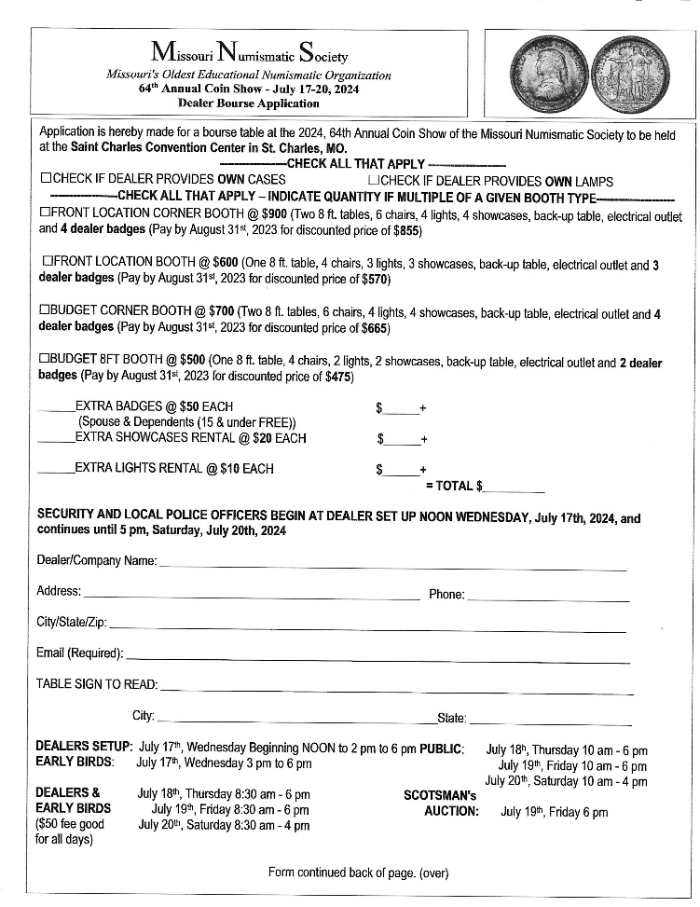
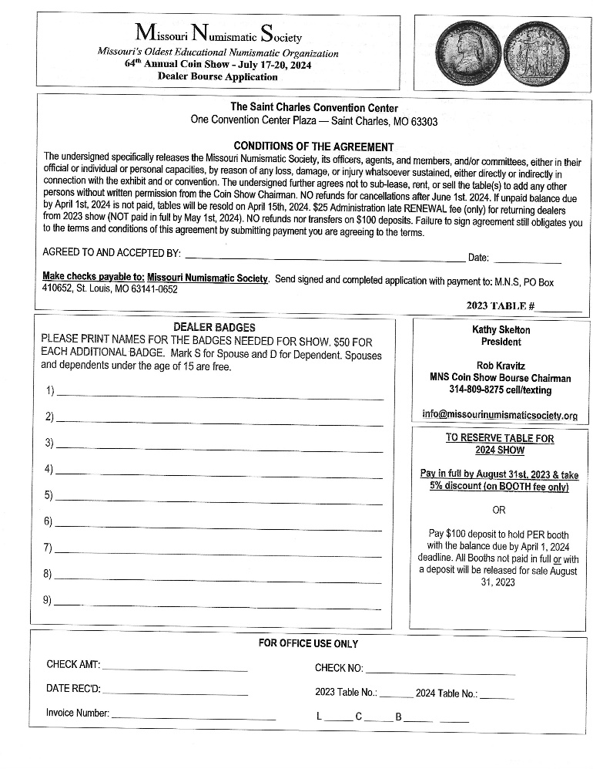
To reserve table for following year show:

Pay in full by July 31st, current year & take 5% discount (on BOOTH fee only) or
Pay $100 deposit to hold PER booth with the balance due by MAY 1st Following Year Deadline
Booths not paid in full or with a deposit will be released for sale September 1 of the current year.

APPENDIX C - TABLE OF OFFICERS, GOVERNORS AND COMMITTEE MEMBERS

Officers and Governors
Title | Name
President | Kathy Skelton
Vice President | Rob Kravitz
Treasurer | Joel Anderson
Corresponding Secretary | Barbara Steers
Recording Secretary | Nick Correnti
Show Chairman | Dan Marion
Young Numismatist Director | Jenkins
Governors | Carl Garrison
 | Dave Hamill
 | Dan Marion
 | Jenkins
 | Dale Bunyard
 | Doug Tomey
 | Chip Vaughn
Committees, Chairmen and Members
Committee | Name and Role
Nominating Committee | Kathy Skelton (President as Chairman)
Property Committee | Joel Anderson (Treasurer as Chairman)
Audit Committee | Kathy Skelton (President as Chairman)
Banquet Committee | Rob Kravitz (Vice President as Chairman)
Membership Committee | Rob Kravitz (Vice President as Chairman)
 | Dave Hamill (Member)
 | Kathy Skelton (Member)
 | Dan Marion (Member)
Show Committee | Dan Marion (Chairman)
 | Dan Marion (Show & Bourse Chairman)
 | Joel Anderson
 | Dave Hamill
 | Barbara Steers
 | Kathy Skelton
 | Doug Tomey
General Meeting Committee | Rob Kravitz (Vice President as Chairman)
Sick and Welfare Committee | Barbara Steers (Correspondence Secretary as Chairman)
 | Kathy Skelton (President)
Publications / Social Media Committee | Kathy Skelton (President as Chairman), Barbara Steers (Correspondence Secretary)
 | Chris Sutter (Editor and Member)
 | Chip Vaughn (Webmaster)
Young Numismatist (YN) Committee | Jenkins (YN Leader as Chairman)
ANA and CSNS Club Representative(s) | Chris Sutter (Member)
MNS Club Auction Coordinator | Carl Garrison
MNS Web Master | Chip Vaughn

APPENDIX D – PUBLICATIONS AND REPORTS

Official Club Publications
Title | Frequency | Responsible
Missouri Journal of Numismatics | Yearly | Publications / Social Media Committee  Editor
MNS Web Site | Updates as Needed | Webmaster
Financial and Operating Reports
Title | Frequency | Responsible
Review of Policies and Procedures | Yearly | President
General Meeting Minutes | Monthly | Recording Secretary
Board Meeting Minutes | Monthly | Recording Secretary
Balances of Checking and Investment Accounts | Monthly | Treasurer
Final Show Report | Yearly | Treasure  Show Chairman
Audit Report | Yearly | Audit Committee
Sick and Welfare Reports | Monthly | Sick and Welfare Committee
Status of the ANA Diploma Program | Yearly | ANA and CSNS Club Representatives
President’s Report | Yearly | President
Ancient Coin Study Group Report | Yearly | Ancient Coin Study Group
Calendar of Events | Yearly | Editor
Young Numismatist Membership Report | Yearly | YN Director
Journal Articles | Yearly (as submitted for the Journal) | Members

APPENDIX D – MNS Club Auction Rules

- Only MNS Members can place lots in the auction.
- Purchasing lots at the auction is open to anyone.
- All sales are FINAL. Since all buyers will have an opportunity to view the auction lots, no returns will be allowed.
- There are no buyer or seller fees.
- There are no reserves and owners may bid on their own items.

- All lots must be numismatic related.
- The MNS Auction Coordinator, has the right to refuse any lot without explanation.
- One of the members of the club will call the auction.

- All lots must be identified before the close of the General Membership Meeting held in the month prior to the auction.
- All lots must be identified by using the MNS Club Auction Lot Entry Form.
- All lots will be displayed at the General Membership Meeting held in the month prior to the auction.
- All lots will be listed in the MNS Newsletter.
- All lots will include: Seller’s name, phone number, a description of the item, Bid Opening amount.

- Each MNS Member may place up to 5 lots in the auction. Two of the five lots are guaranteed, and up to three additional lots may be permitted if space is available for the additional lots.
- The maximum number of lots in the auction is 75.
- The minimum value for each lot is $15.00.
- Minimum bidding increments are $1 up to $50, $5 increments from $50 to $200, $10 increments from $200 to $500, and then $25 increments above $500.

- Display cases will be provided for members to view the lots at the General Membership Meeting held in the month prior to the auction, and at the General Membership Meeting in which the auction will be held.
- All items will be kept by the consignor and brought to the General Membership Meeting held in the month prior to the auction, and again at the auction.
- No MNS Officer or Board member will take physical possession of any item. The MNS will not obtain title to any item.
- New lots are permitted to be added the night of the auction. However, new lots presented less than 30 minutes prior to the start of the General Membership Meeting may be refused entry into the auction due to time constraints.
- All Lots will be submitted using the MNS Club Auction Entry Form (Template attached below) and recorded in the MNS Club Auction List (Template attached below). The following will be recorded in the list:
  - Lot Number
  - Description
  - Consigner’s Name
  - Estimated Value Range
  - Suggested Opening Bid
  - Hammer Price
  - Buyer
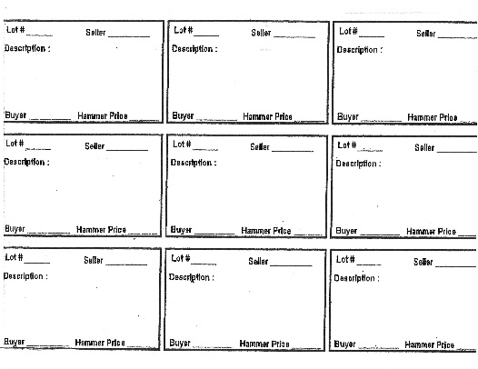

- All sales will be in Cash.

- Following the auction of the last item, payments for the items purchased will be accepted by the MNS from the buyers.
- After all buyer payments have been received, the MNS will make payments to the sellers.

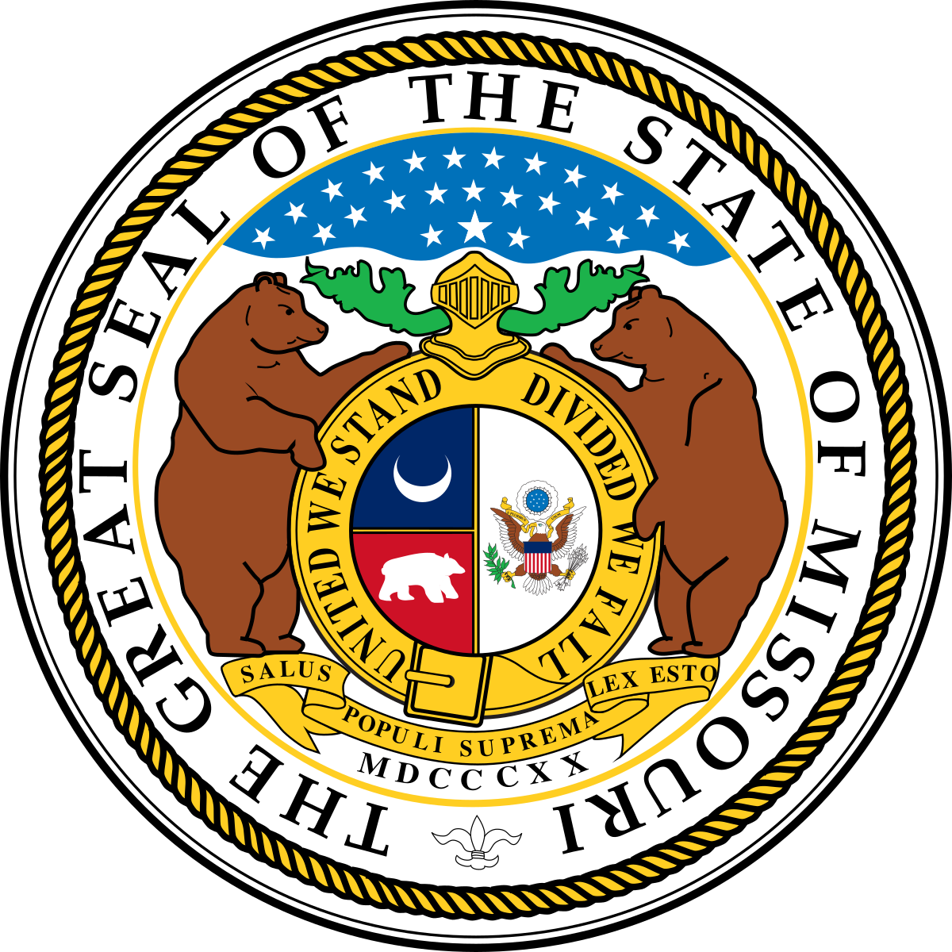

This Photo by Unknown Author is licensed under CC BY-SA

End of Document

